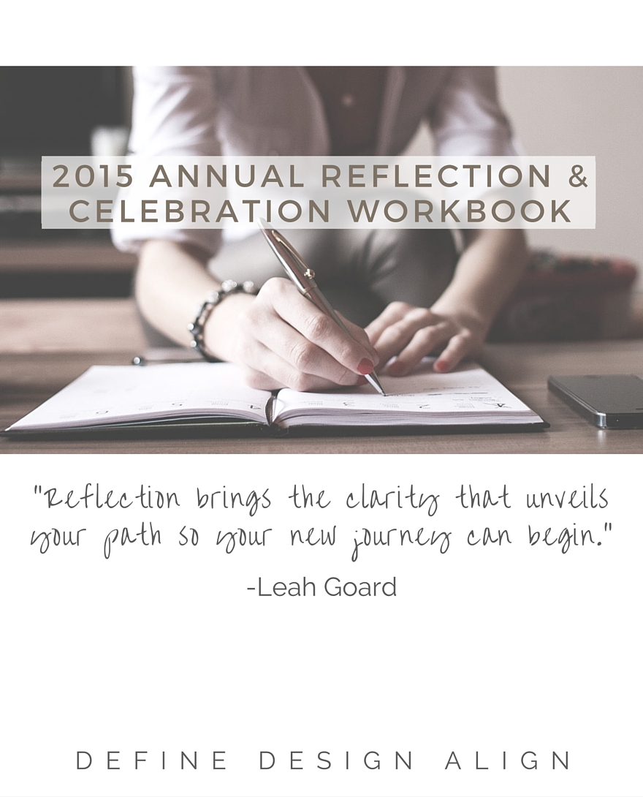


2015 Business Reflection, Celebration + Relase

- Describe how you predominantly felt in your business throughout 2015?

- What are your greatest business high fives in 2015?

- What worked well in your business that you will bring forward into the New Year?

- What are your greatest business lessons of 2015?

- What didn’t work well in your business and why? What will you do differently to improve it?

- What marketing really worked this year that you will carry forward and build on in the New Year?

- How do you feel about your financials this year? Did you reach your financial objectives?

- What financial lessons have you learned this year and what are you going to bring forward or do differently in the New Year?

- If you could wave a magic wand, what three things would you change in your business that would make the biggest impact?

2015 Personal Reflection, Celebration + Relase

- Describe how you predominantly felt personally throughout 2015?

- What are your greatest personal high fives in 2015?

- What worked well in your personal life that you will bring forward into the New Year?

- What are your greatest personal lessons of 2015?

- What didn’t work well personally and why? What will you do differently to improve this/ these?

- If you could wave a magic wand, what three things would you change in your personal life that would make the biggest impact?

- What are you most grateful for this year?

Use this space to write down anything else that you want to capture, share, vent, release from this year.

