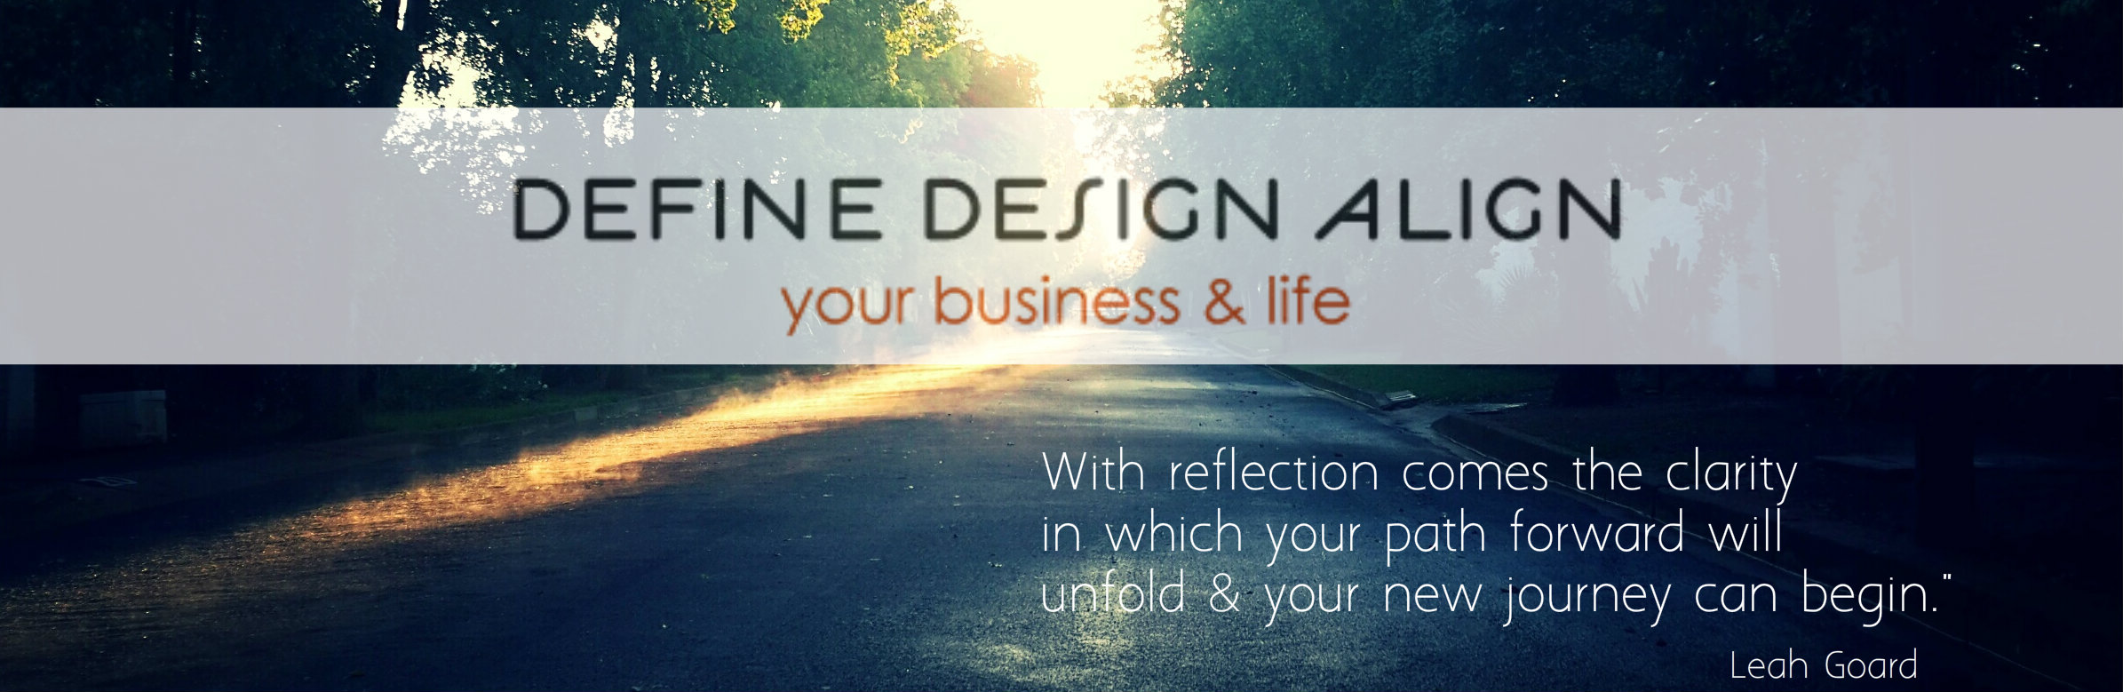
2014 Mid Year Land + Launch
- Three words to describe how you have predominantly felt during the first half of 2014?

- What are your top personal + professional high fives so far this year?

- What were the most important things you set out to accomplish at the beginning of the year?

- Are you en route to achieve / gain traction in those key areas or is your business and life calling you to focus on something different? If yes, what is it? What has unfolded in your world?

- What is working well in your personal life? What do you want to shift or change?

- What is working well in your business/ career? What do you want to shift or change?

- What are your greatest lessons learned so far this year?

- What is your greatest fear right now and the biggest Agreement that has been an under-current for you this year so far?

- If you could wave a magic wand, what would you accomplish, do, change or shift by the end of 2014?

With the insight you have unveiled in the questions above, turn them into new / adjusted action items and move them into your plan to create the change you desire.

